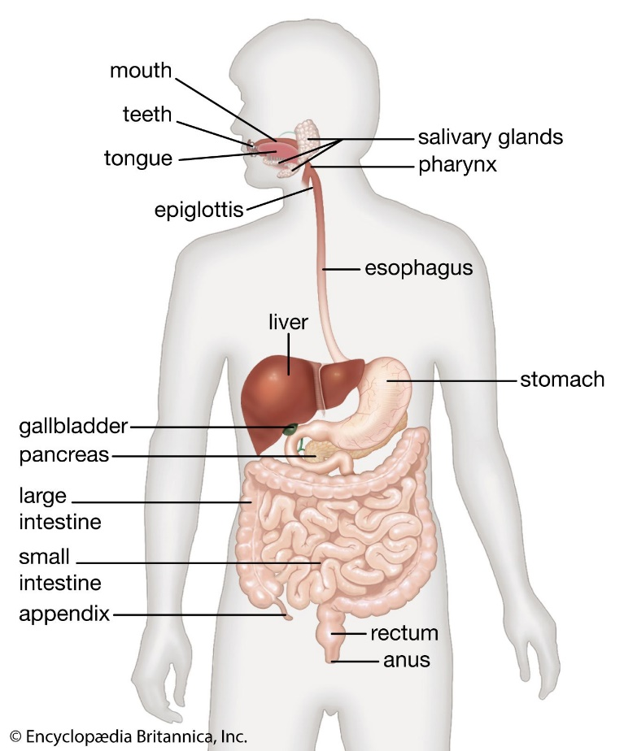

<https://www.britannica.com/science/human-digestive-system>

**Journey of Rice**

**Mouth and Oesophagus**

The rice enters the mouth where it is chewed, incisors biting and cutting the rice, canines tearing, premolars and molars crushing and grinding which is mechanical digestion, physically breaking down it down into manageable chunks. Then the tongue mixing saliva creating a ball like form called bolus, salivary amylase is secreted by the salivary glands of the mouth. It acts on the starch in food and breaks it down to maltose. The bolus then gets pushed down pharynx where epiglottis closes to go down the oesophagus. The oesophagus pushes the bolus down through muscle constriction, peristalsis, secreted mucus lubricates the bolus.

**Stomach**

The stomach is involved in both mechanical and chemical digestion. The stomach churns by waves of muscular contractions, mixing it with gastric juices made of digestive enzymes, mucus and hydrochloric acid, making a substance called chyme, a thick semifluid mass of digested food and digestive secretions. Though the digestion of starch is brought to a stop due to low acidic pH of gastric juice (1.5-2), stopping the salivary amylase. The little amount of protein in rice is broken down by the enzymes pepsin into amino acids, making it easier to be to be absorbed into blood.

**Small Intestine**

**Breakdown:**

Chyme now enters the Duodenum, where pancreatic juices from pancreas, bile made from liver which is stored and concentrated in the gallbladder gets secreted into the small intestine and mixes with the chyme. Enzymes in pancreatic juice breakdown starch into monosaccharides glucose (basic form of carbohydrates). The fat in rice is broken down fatty acid and glycerol by bile as well. Now liquified chyme goes through the jejunum then ileum where absorption takes place.

***Absorption:***

By this stage carbohydrates are now monosaccharides glucose, protein into amino acids and fat into fatty acid and glycerol. Mucosa, the inner lining of the small intestine, which is folded therefore increasing surface area, is covered by villi a hair-like projections. The villi are also covered by hair-like projections called microvilli. Isn’t that cute. Inside the villi are lymph capillaries called lacteal, which is surrounded by a network of blood capillaries.

Fatty acids, glycerol and water are absorbed through simple diffusion, in the cells of the villi fatty acids and glycerol recombine to form fats and enter the lacteals, while amino acids and glucose are absorbed by active transport into the blood capillaries, they pass through the cells on the outside of the villi and into blood capillaries. Nutrients enter the capillaries to be circulated through the body. Nutrient that isn’t absorbed moves into the large intestine.

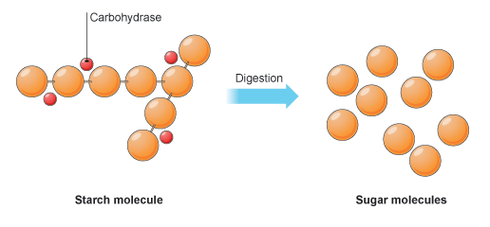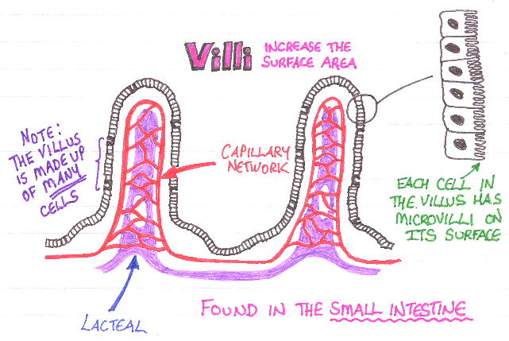

<https://socratic.org/questions/why-do-we-have-villi-in-the-small-intestine> & <https://pmgbiology.com/2019/07/31/starch-digestion-grade-9-understanding-for-igcse-biology-2-29/>

**Material breakdown and use**

Glucose is the main product of rice, and glucose is the main source of fuel for the body’s cells, it’s used for energy. Fatty acids are used as energy storages. Amino acids are used for protein synthesis, which help with the growth and repair of the body.

**Large intestine**

The remaining nutrients move into the large intestine, remaining water from the chyme, minerals and some vitamins, turn into a more solid substance called faeces. Carbohydrates that aren’t digested in the small intestine get digested by colonic bacteria.

**Elimination and Faeces**

From the large intestine, the compacted waste to the rectum as faeces. Rectum is the last part of the large intestine, where faeces are pushed by peristalsis, as rectum stretches thy trigger response known as defaecation. Muscles around anus relaxes and faeces can be passed.

**References**

*Describe the digestion of rice: type, location(s), enzyme(s), and chemical breakdown | Wyzant Ask An Expert*. (n.d.-b). Wyzant Tutoring. <https://www.wyzant.com/resources/answers/778780/describe-the-digestion-of-rice-type-location-s-enzyme-s-and-chemical-breakd>

Ndtr, S. G. (2022b). Starch Digestion: What You Need to Know. *LIVESTRONG.COM*. <https://www.livestrong.com/article/488214-starch-and-digestion/>

*Difference Between Small and Large Intestine*. (2022). UMPC Children’s Hospital of Pittsburgh. Retrieved May 8, 2023, from <https://www.chp.edu/our-services/transplant/intestine/education/about-small-large-intestines>